This week we will be reading Story 26, “The Mysterious Tadpole.” The students will be reviewing what a fantasy story is and its characteristics. Also, we will be reviewing story structure, making conclusions, and multiple-meaning words. Students will be spelling words with oo, ew, ue, and ou. In Grammar, the students will be reviewing what a contraction is and the two words which make up a contraction.

**High-Frequency Words:** again, ago, alone, don’t, every, follow, goes, head, now, won’t

**Vocabulary Words:** ordinary, control, cage, upset, sensible, confused, training, suspiciously

**Reading Test:** Friday, April 25th

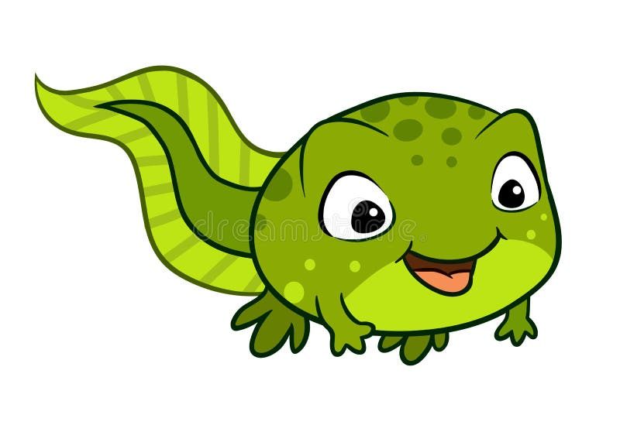

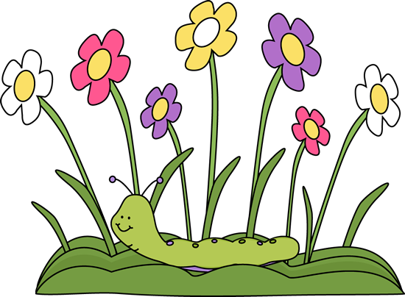

**Science/Social Studies**

coAlar

In Science, we will be continuing to work on our Animal Research projects we started before Spring/Easter Break. Also, we will be reviewing what we learned about habitats by completing cause/effect and sorting activities. Also, we will be reviewing the vocabulary that we learned.

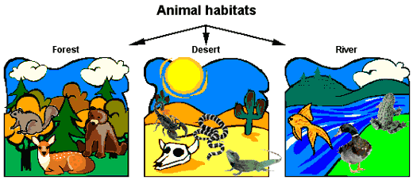

In Social Studies, we will be continuing to learn about how our government works. Students will be learning why rules exist and what happens when you do not follow those rules.



Highlands Elementary School

Week of April 21st-25th,2025

This week in Math, we will be reviewing concepts previously taught. On Wednesday, we will be adding by decomposition. Also, we will be practicing previous concepts on the Innovamat App.

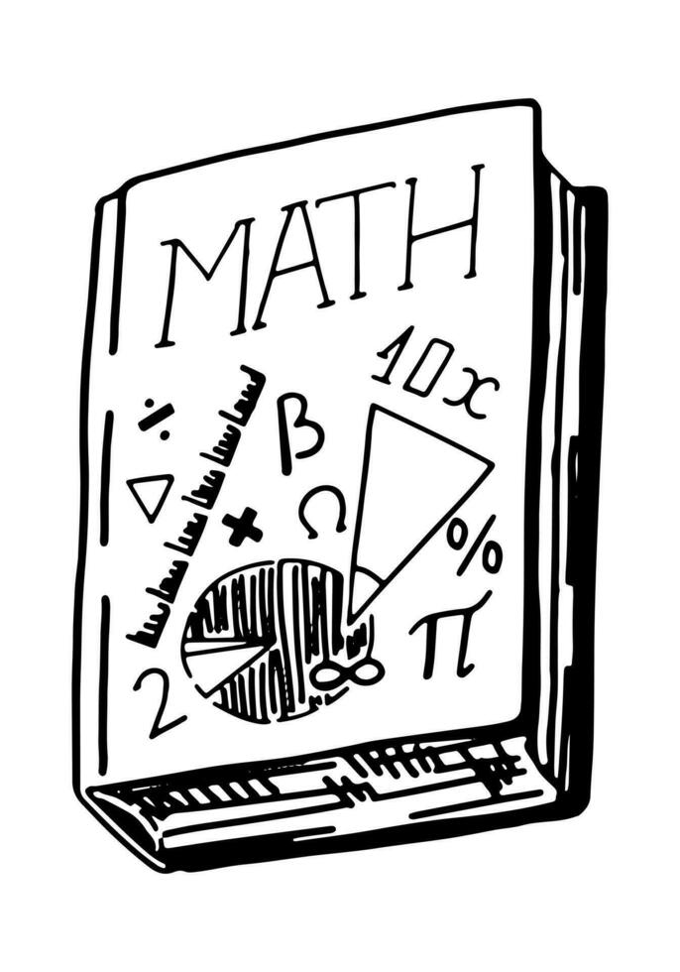

Miss McCurdy’s Classroom Newsletter

# Math

# Language Arts

banner with apples and crayons

**Wednesday, April 30th**: Superintendent’s Coffee Talk & Title 1 PAC Meeting VIA Zoom HEDD & HES—1:45 P.M.

**Thursday, May 1st:** Physical Education Week

**Friday, May 2nd**: National School Lunch Heroes Appreciation Day

**Monday, May 5th-Friday, May 9th:** National Teacher Appreciation Week/Highlands Staff Appreciation Week

**Thursday, May 6th:** 4th Grade Spring Choral Concert—6:00 P.M. @ HES

**Sunday, May 11th:** HAPPY MOTHER’S DAY!

**Wednesday, May 21st**: 4th Grade Spring Band Concert—6:00 P.M.

**Monday, May 26th:** MEMORIAL DAY! NO SCHOOL FOR STUDENTS/STAFF

# This Week’s Happenings!

## Upcoming Events

Many students are coming in with their Chromebooks not charged. ***Please make sure you are having your child “charge” their Chromebooks nightly.***



**Parent’s Corner**

**Language Arts:** Review high-frequency and vocabulary words on study guide; Re-read pages 384-405 in Student Reading Book or listen to story on Think Central

**Math:** NONE

**Science:** NONE

**Social Studies:** NONE



Miss McCurdy’s Classroom Newsletter Page 2

# This Week’s Assignments

*In Reading/ELA, we began working on our Animal Research Projects.

*In Math, the students completed the Check in Test #5. Also, they participated in the “Math Festival.” Ask your child what they did.

* In Science, the students continued to learn about different habitats and their characteristics.

*In Social Studies, the students learned what a community is and what makes it up.



Monday-

NO SCHOOL FOR STUDENTS/

STAFF

SPRING/EASTER BREAK

Tuesday-

Earth Day!

Schools Re-Open

Day 4

Regular Schedule

Music

Wednesday-

Day 5

Regular Schedule

Art

Thursday-

Day 6

Regular Schedule

Physical Education *Wear Tennis Shoes

Friday—

Day 1

Regular Schedule

Foreign Language Class

## Second Grade Buzz C:\Documents and Settings\Administrator\Local Settings\Temporary Internet Files\Content.IE5\SJHPR24O\MC900353704[1].wmf